Quebec Today:
Culture, Politics & Exchange
Taught in English
Spring 2014

Rutgers-Camden Online Schedule Listing:
Learning Abroad Program in French: 50:420:387

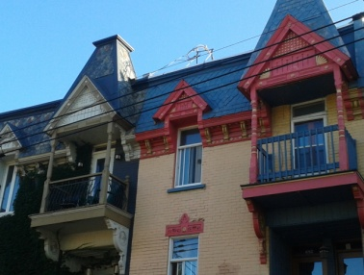
Course Meetings:
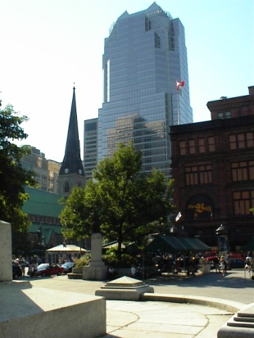
Course Number: 50:420:387

Instructor: Dr. Alisa Belanger
Office Hours: Monday: 3:30 – 4:30 pm
Thursday 1:30 – 3:30 pm
or by appointment
Office: 472 Armitage Hall
Email: alisa.belanger@rutgers.edu

CLASS MEETING DATES : TRIP TO QUEBEC DATES:

Tuesday 6:00 – 8:40 pm June 15 – 25

Feb. 11
Feb. 25
March 11 APPROXIMATE COSTS:
March 25 Trip Fee: $1450
April 8 Roundtrip Transportation (NJ <-> Montreal): $ 150
April 22 Food & Incidentals on Trip: $ 200
May 6 $ 1800

Course Description.

Taught in English, this course aims to introduce students to contemporary Quebec society. More than merely a ‘cross’ between French and American cultures, Quebec has developed a unique identity across time, transforming from a rural and predominantly Catholic society, into an international center for multicultural and multilingual diversity. Also home to successful businesses that serve both English- and French-speaking clients throughout the world, Quebec (considered on par with countries) is the United States' 13th largest trading partner, making it important to understand the culture and politics of those with whom we engage in exchange.

In order to reach a broad understanding of Quebec today, students will examine eight major themes in sources ranging from socio-historical and literary texts, to the visual arts and new media.

- The History of New France
- Language & Politics
- Sovereignty & Canadian Federalism
- Natural Resources, Food & Agriculture
- First Nations Policy Issues
- Immigration History & Debates
- Gender & LGBTQA Culture
- Contemporary Digital Media & Performance Arts

The Learning Abroad Study Tour that will conclude this course will offer students an opportunity to visit the cosmopolitan city of Montreal, the historical streets of Old City Quebec, and the innovative museum-hotel resort located on the Wendake First Nations Reservation. The last full day of the trip, June 24, 2014, falls on the Quebec National Holiday (la Fête Saint Jean Baptiste) with free concerts and events attended each year by thousands expressing their Quebec pride.

Learning Objectives.

By the end of this course, students will be able to:

- Identify ways that Quebec is culturally unique in North America
- Explain the “sovereignty question” and the importance of the French language in Quebec
- Outline the on-going evolution of First Nations Rights in Quebec
- Describe significant cultural differences between Quebec and the U.S.
- Compare Quebec and U.S. attitudes toward immigration, education, gender and the environment

Course Materials. Please note that the following title is required. Additional resources will be posted on Sakai.

Dickinson, John A. & Brian Young. A Short History of Quebec. McGill-Queen’s University Press: Montreal, 2008. 4th Edition. ISBN: 0773534407.

Course requirements.

Participation: 20%
Synthesis papers (x4): 40%

Interaction Questions: 5%
Documentary File: 15%
Final Paper or Video: 20%

Attendance Policy.

Since this course meets only on a bi-weekly basis, students who are taking the course for credit are allowed just 2 unexcused absences. Your overall final grade will be lowered by 10% if you miss 3 classes without official documentation (i.e. a doctor's note, permission from the Dean or your advisor, etc.). Should you miss 4 classes or more without an excuse, then you will automatically earn an “F” in the course.

If you are absent for any reason, it remains your responsibility to catch up on what happened in class and complete your assignments for the next class. Please contact colleagues in the course before coming to see me to learn what you have missed.

Class Participation.

You should arrive prepared to participate actively. Your engagement in discussion is not only important for your participation grade (20%), but also for the dynamics of the class and your group learning. I expect you to speak to each other as much as you speak to me and to be respectful of your peers, regardless of their background or differences. This policy pertains to listening as well as speaking.

The following rubric will be used to evaluate participation:

Grade | Student behavior
A | - Asks questions, initiates discussion, volunteers comments without prompting  - Always well-prepared, participates actively but allows other students to speak, as well  - Makes relevant comments citing details in the texts, images or materials studied  - Makes the most of each group activity with his or her partner(s) or group  - Attempts to extend his/ her learning to new material  - Always respectful to others
B-B+ | - Usually well-prepared, often participates, but sometimes waits to be called upon  - Asks questions and completes group activities as required, but without pursuing further  - Makes vague or general comments (recycling others’ ideas, etc.)  - Usually participates well in group activities but requires others to take the lead  - Always respectful to others
C-C+ | - Often not prepared for class, participates minimally and not spontaneously  - Rarely speaks without being called upon  - Makes vague or general comments, responds “I don’t know” to opinion questions, etc.  - Occasionally disrespectful to others (scoffing, talking during presentations, etc.)
F | - Rarely prepared, often late, or absent  - OR Frequently disrespectful to others (scoffing, talking during presentations, etc.)  - OR Unable to provide relevant comments even when called upon and assisted

Tardiness.

You are expected to arrive on time. Tardiness is disrespectful to your classmates. For every two (2) times a student arrives more than 10 minutes late to class, he or she will be assessed one (1) unexcused absence. After the first three (3) unjustified absences, the final grade will be reduced by 10%, etc., whether these unjustified absences are accumulated due to late arrivals or not showing up at all.

Synthesis papers.

You will be required to write four papers that synthesize multiple readings or materials studied through the course of the semester. In every case, this homework should be typed, double-spaced, and thoroughly proofread. These papers should demonstrate a grasp on the material already covered in class and the ability to analyze questions critically on your own.

No late written assignments of any kind will be accepted for any reason without a grade deduction, to be determined at the whim of your professor. I reserve the right not to grade or return late papers. Hand it in on time if you want to get it back!

Interaction Questions.

Based on course readings, you will be asked to prepare a file of 4-5 questions to ask the guest speakers who will be invited to present to our group based on their areas of expertise in Quebec, as well as a short interview for a Quebec resident. The questions for guest speakers will be graded for the degree to which they illustrate an understanding of the relevant topics studied in class. You will be required to ask at least three of them over the course of the trip, as well as to share the outcome of your interview with a Quebec resident.

Final Paper or Video.

Near the end of the course on campus, you will formulate a central question that you hope to explore independently during the trip. Ideally, it will be related to your own academic focus. During the trip, you will create a “documentary file” related to your central question: it may include photographs, video, audio recordings, hand-outs, notes, objects, etc.

Upon returning to the U.S., you will write a 4-5 sentence summary describing each item in your documentary file and its importance to understanding the topic that you chose for your central question. You may then either compose a traditional academic paper on the topic (7-8 pages) or transform your documentary file into a short film on video (5-10 minutes) to submit to me as your Final Paper or Video.

Academic Integrity:

All written assignments that you hand in for class must represent your own original work. You may ask a peer to help you, but your text needs to reflect your own knowledge: i.e. you must be able to explain to me spontaneously in your own words any changes made to your text based on others’ suggestions. Be aware that many websites on literature contain significant errors and that online translators are highly ineffective.

A student will receive an F in the class and will be reported if he or she breaches the Academic Integrity Policy in any way. Consequences for violations have been outlined by Rutgers-Camden: http://www.camden.rutgers.edu/RUCAM/Academic-Integrity-Policy.php

Plagiarism:
The outline of Academic Integrity includes the following definition: Plagiarism is the representation of the words or ideas of another as one's own in any academic exercise. To avoid plagiarism, every direct quotation must be identified by quotation marks or by appropriate indentation and must be properly cited in the text or in a footnote. Acknowledgment is required when material from another source stored in print, electronic or other medium is paraphrased or summarized in whole or in part in one's own words. To acknowledge a paraphrase properly, one might state: "to paraphrase Plato's comment..." and conclude with a footnote identifying the exact reference. A footnote acknowledging only a directly quoted statement does not suffice to notify the reader of any preceding or succeeding paraphrased material. Information which is common knowledge such as names of leaders of prominent nations, basic scientific laws, etc., need not be footnoted; however, all facts or information obtained in reading or research that are not common knowledge among students in the course must be acknowledged.

Special Needs.
Rutgers, the State University of New Jersey abides by the Americans with Disabilities Act of 1990, the Americans with Disabilities Act Amendments (ADAA) of 2008, and Sections 504 and 508 which mandate reasonable accommodations be provided for qualified students with disabilities and accessibility of online information. If you have a disability and may require some type of instructional accommodation, please contact me early in the semester so that I can provide or facilitate in providing accommodations you may need. If you have not already done so, you will need to register with the Office of Disability Services, the designated office on campus to provide services for students with disabilities. The Office of Disability Services is located in the Rutgers-Camden Learning Center; Armitage Hall, Room 240 (856) 225-6443.

Course Outline

Meeting 1 The History of New France__________________________________________________________________
A Short History of Quebec –Chapter 2 (p. 28-65) “Pre-Industrial Quebec, 1650s-1810s”
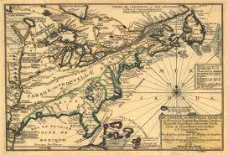
Topics: The fur trade
Rural society and Catholicism
La Chasse galerie (in English)

Meeting 2 Language & Politics _________________________________________________________________________
A Short History of Quebec – Chapter 9 p. 305-344 “The Quiet Revolution”
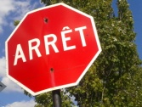
Topics: From WWII to World Expo ’67
Les Ordres (1974, film) and The October Crisis
Charter of the French Language (Law 101)

Meeting 3 Sovereignty & Canadian Federalism_______________________________________________________
A Short History of Quebec – Chapter 5 (p. 154-197) “Politics and Institutions, 1810s-1880s”
Topics: The Patriots, 1837 Rebellion & Lord Durham Report
The repatriation of the Constitution (1982)
Referendums (1980 & 1995)

Meeting 4 Natural Resources, Food & Agriculture____________________________________________________
A Short History of Quebec – Chapter 6, (p. 198-237) “Industrial Capitalism, 1890s-1930s”
Topics: Traditional foods & contemporary cuisine
(Organic) farming/ mining industries
Hydroelectric Power (HydroQuébec)

Meeting 5 First Nations Policy Issues__________________________________________________________________
A Short History of Quebec – Chapter 1 (p. 3-27) “Native People and the Beginnings of New France”
Topics: Wakiponi mobile (short films)
“Twistory” & the Oka Crisis
First Nations governments

Meeting 6 Immigration History & Debates____________________________________________________________
A Short History of Quebec – Chapter 10 (p. 345-378) “Contemporary Quebec: A Distinct Society”
“Immigration and Diversity in Quebec's Schools: An Assessment,” Marie McAndrew, in Quebec Questions (2010)

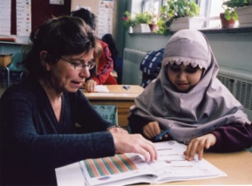
Topics : La Classe de Madame Lise (2006, film)
Immigration in Quebec education
Taylor-Bouchard Commission & Charter of Quebec Values

Meeting 7 Gender & LGBTQA Culture_________________________________________________________________
“Queer Nations: Nationalism, Sexuality and the Discourse of Rights in Quebec,” Carl Stychin in Feminist Legal Studies5.1 (1997) 3-34.

Topics: C.R.A.Z.Y. (2005, film)
Women’s rights & Quebec feminism
Sexuality and gay marriage rights in Quebec

Meeting 8 Contemporary Digital Media & Performance Arts_________________________________________
Patrick Cohendet, et al. “The Anatomy of the Creative City,” Industry and Innovation, 17:1 (2010) 91-111.

Topics: Video Games (Ubisoft)
Performance Arts (Cirque du Soleil, etc.)
Montreal Festivals

* Please note that all films will be in English or subtitled in English.
Documents related to each topic will be made available on Sakai.

